

Continuous Integration & Continuous Delivery

(CSDV3109)

Submitted to: **Dr**. **Hitesh Kumar Sharma**

Name: **SIDDHARTH TIWARI**

SAP ID: **500095935**

Batch: **BTech** **CSE** **DevOps**-**B3**

INDEX:

|  |  |  |  |
| --- | --- | --- | --- |
| Sno. | Experiment | Date | Sign |
| 1. | Installation Of Jenkins |  |  |
| 2. |  |  |  |
| 3. |  |  |  |
| 4. |  |  |  |
| 5. |  |  |  |
| 6. |  |  |  |
| 7. |  |  |  |
| 8. |  |  |  |
| 9. |  |  |  |
| 10. |  |  |  |
| 11. |  |  |  |
| 12. |  |  |  |

***Experiment-1***

1. Install all the updates

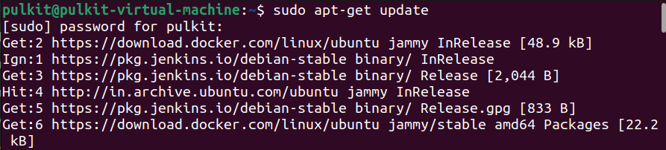

1. Install Java version 11

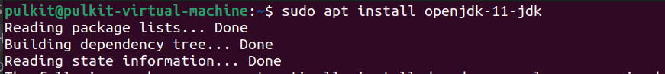

1. Install Jenkins

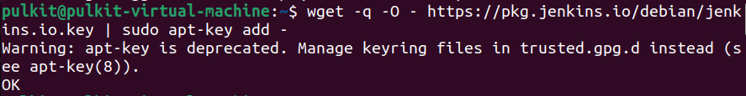

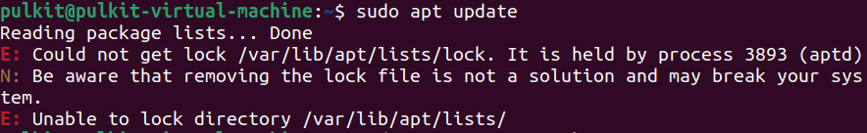



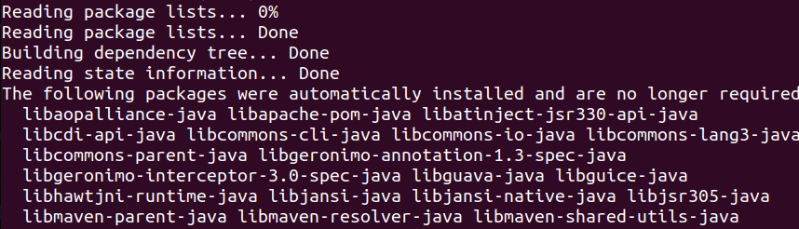

1. Jenkins Plugins installation

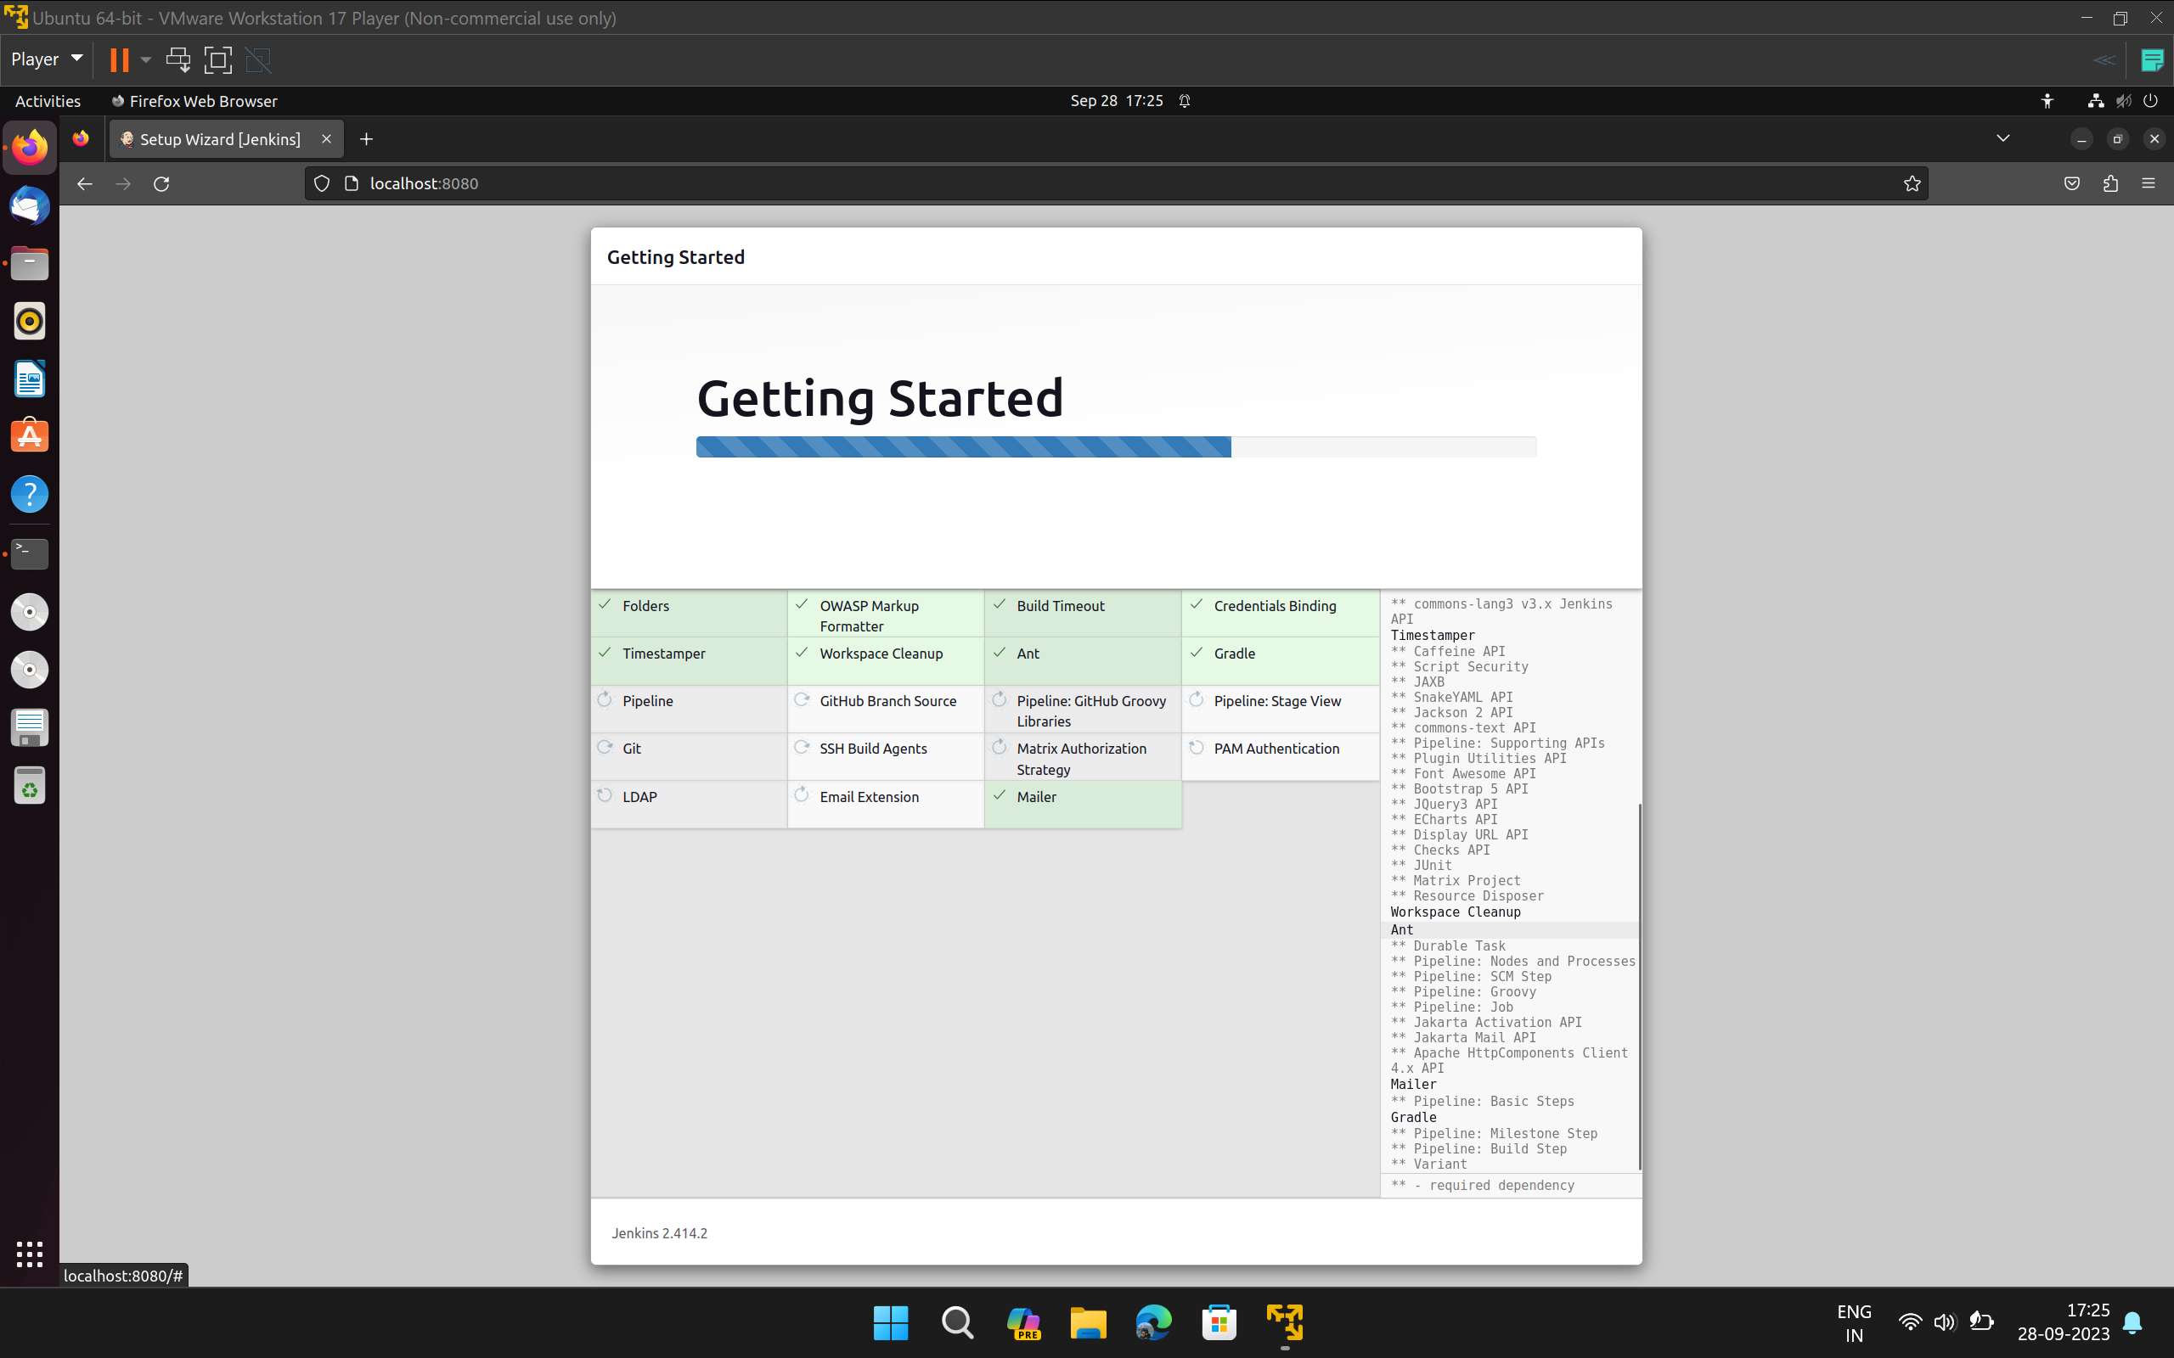

1. Credentials set-up and home page

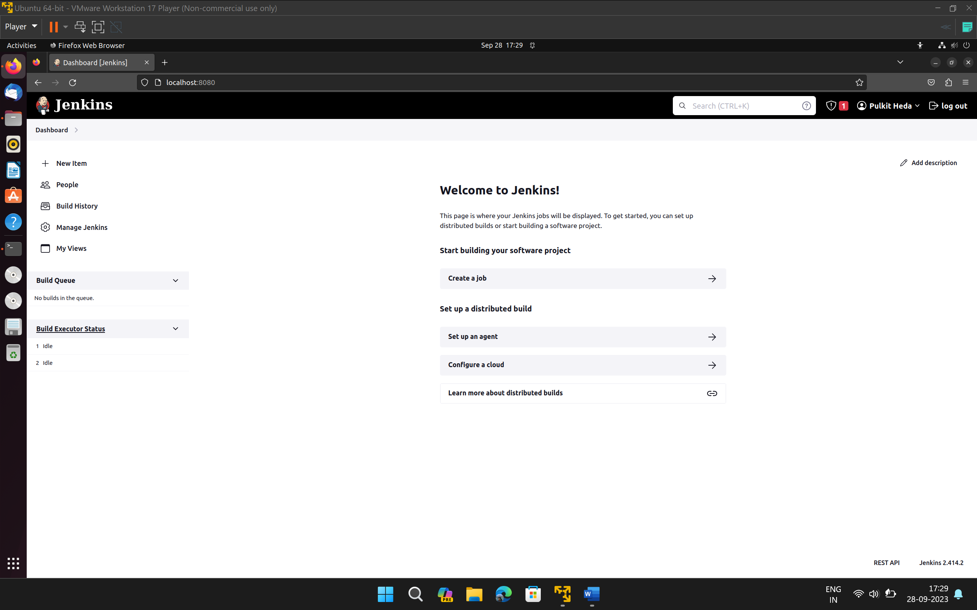

1. Install Maven Plugin

